Examining the Change in Gender Turnout Between Rounds of the 2014 Afghan Presidential Election

Naomi Giertych

The Afghan government in recent decades has been attempting to uphold a high standard of transparency with its voters and the world. As part of this initiative, the National Democratic Institute publishes data from Afghan national elections and reports statistics about voter turnout, voter gender mix, and election results. The most recent election data available is the presidential election on April 5, 2014 and the runoff election on June 14, 2014. The presidential election on April 5, 2014 presented 11 candidates to the voters, and the runoff election pit the top two candidates, Abdullah and Ghani, from the first round against each other. For this report, I will be exploring the change in the female voter turnout between the first round and the second round of the presidential election in 2014.

To address this topic, I use data from the National Democratic Institute and the Independent Election Commission of Afghanistan. The election results datasets contain voter counts for each candidate by polling station, where every polling station belongs to a province, district, and polling center. The polling center is the physical building in which one votes, and the polling station is the kiosk at which one votes. There are 34 provinces and approximately 380 districts. Note, the districts between the datasets are not entirely consistent; I use all of the unique values of the districts. The voter turnout data has information on the number of votes by males and females obtained for each candidate at the province level. After merging the data together, a total of 28 provinces remained.[1]

Before examining the change in the voter turnout for females between the first and second round elections, I estimate the change in the overall voter turnout between rounds. To do this, I calculate the difference in the number of votes for each polling station and then regress this difference against the vote totals for all candidates in the first round. Below is a table of the results (model 1).

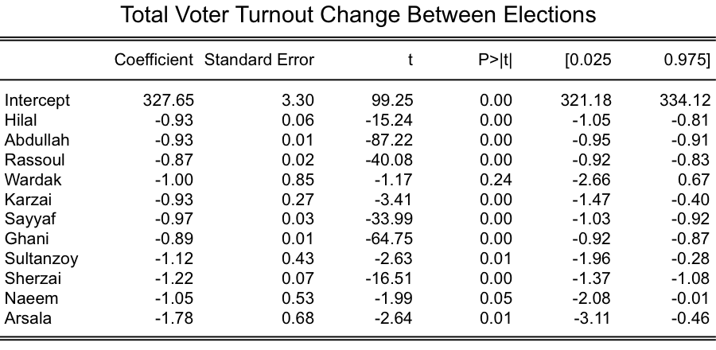

The coefficients of all the candidates in the regression model are negative in the results above. This reflects that overall turnout for the second election was lower than in the first election. Additionally, the coefficients above suggest that the difference in turnout may be correlated with how regions voted for a candidate. For instance, polling stations with greater vote totals for Arsala in the first round had a much lower voter turnout than polling stations that originally voted for Rassoul.

To determine how female voting behavior changed between elections, I examine the distribution in the change in female voter participation and fit separate regressions for the round two candidates Abdullah and Ghani. Though overall voter participation declined, the percentage of female voters increased between elections with most polling stations experiencing almost a 14 percentage-point increase. To examine how female voter participation changed controlling for candidate preferences, I regress each of the round two candidate votes with round one votes for all of the candidates and the percentage-point change in the percentage of female voters (diff_f_turnout) between round one and round two (model 2). Below is a table of the results.

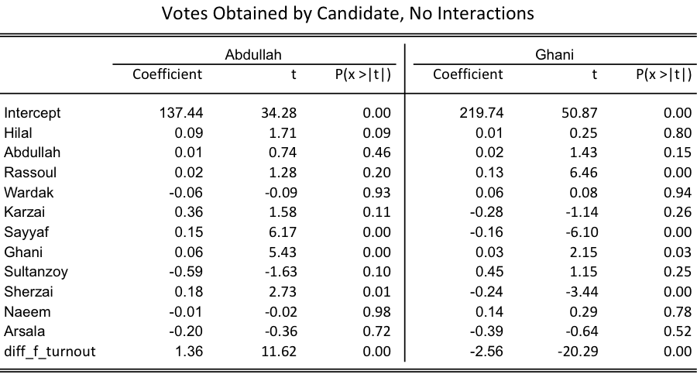

The results above suggest that the difference in the percentage of female voters explains much of the variation in the number of votes obtained for the candidates. However, this may indicate that the overall change in voter participation was a driving factor for the second round votes. Interestingly, the number of votes for Abdullah is positively associated with an increase in the percentage of female voters, whereas the number of votes for Ghani is negatively associated. This suggests that female voters rallied behind Abdullah between the first and second rounds.

Since the total change in participation suggested that turnout may be dependent on the candidate (model 1), I include an interaction term between the change in female participation and the vote counts for each candidate in round 1. Below is a table of the results.

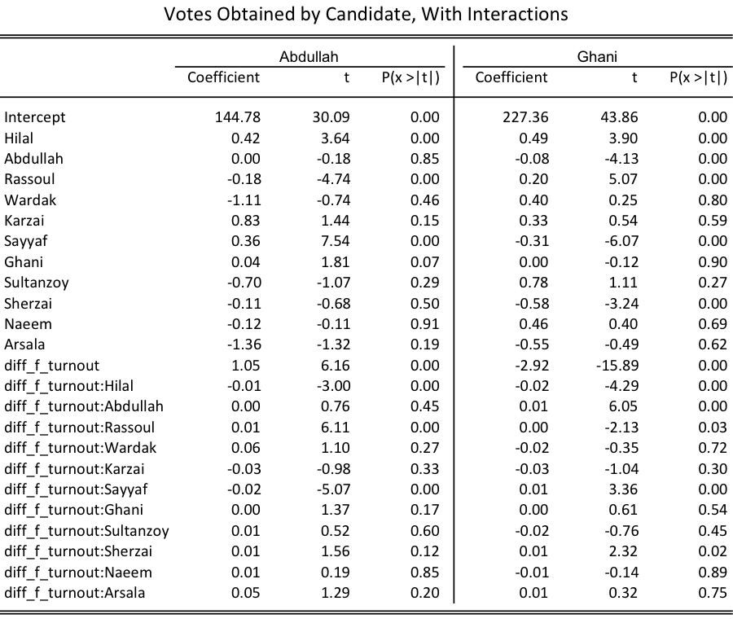

The results above suggest that there is a small relationship between the change in percentage of female voter participation and the candidate voted for in round 1. For instance, communities supporting Wardak in rund 1 generally did not strongly support Abdullah in the second round, but the interaction term indicates that in communities with more participation of female voters, support for Wardak in round 1 predicted increased support forAbdullah in the second round. Overall however, these interaction terms do not greatly change the total support for each candidate as compared to the other coefficients.

The 2014 Afghan election results offer some insights into voter preferences based on changes in the percentage of female voters between the first and the second rounds. Although voter turnout decreased between election cycles, the percentage of female voters vastly increased. Comparing the regression models for each of the round two candidates, I concluded that increases in female participation is positively correlated with support for Abdullah and negatively correlated with support for Ghani. Finally, I suggest that female participation may depend on support for the round one candidate and control for this relationship by including interaction terms. These interaction terms suggest that there may be a small relationship between these variables.

Sources:

Afghan 2014 election data and first round voter turnout:

<http://2014.afghanistanelectiondata.org/about/>

Afghan 2014 runoff election voter turnout

<http://www.iec.org.af/results/pdf/RunOff/en/VotesByCandidateSummary.pdf>

1. Some of the provinces were dropped due to inconsistencies in spelling or other issues.